Assignment for Next Thursday. (I will be taking it up)

A university consists of a number of departments. Each department offers several courses. A number of modules make up each course. Students enrol in a particular course and take modules towards the completion of that course. Each module is taught by a lecturer from the appropriate department, and each lecturer tutors a group of students

Entities

A university consists of a number of departments. Each department offers several courses. A number of modules make up each course. Students enrol in a particular course and take modules towards the completion of that course. Each module is taught by a lecturer from the appropriate department, and each lecturer tutors a group of students

**Steps in building an ERD**

Developing an ERD The process has ten steps:

1. Identify Entities

2. Find Relationships

3. Draw Rough ERD

4. Fill in Cardinality

5. Define Primary Keys

6. Draw Key-Based ERD

7. Identify Attributes

8. Map Attributes

9. Draw fully attributed ERD

10. Check Results

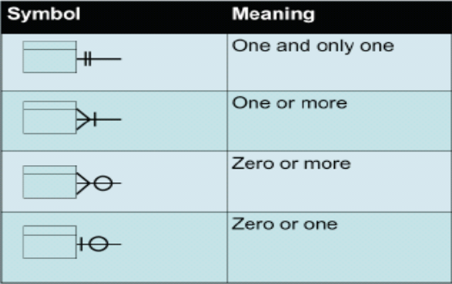Cardinality Notation